**Assignment 2**

**Part 1:**

**Question_1**

Question_1_A: Provide the top10 countries which have received the most refugees in a 2015

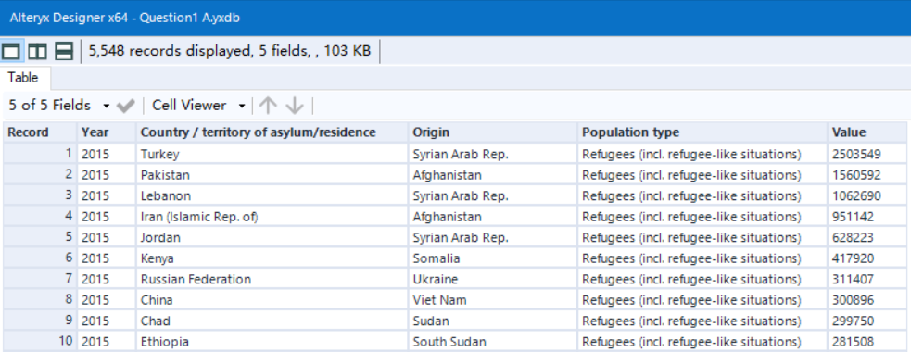

Question_1_B: Provide the top10 countries which are the highest “generators” of refugees in 2010

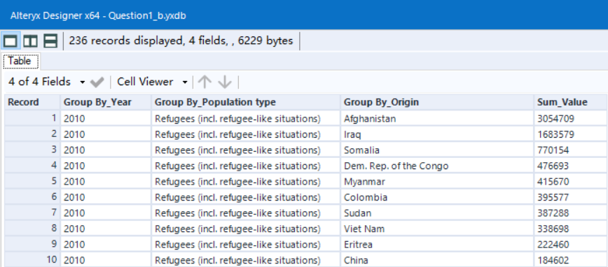

Question1_C:

**Given the data you see, explain at least 5 other questions you answer with the data:**

**Question1:**

As we can see on the data in 2015 Syrian Arab pep generates lots of the refugees. But in 2010 the top 10 generators, There are no Syrian Arab pep. Is that means there are something bad happened During these 5 years that make this country generates lots of refugees?

**Question2:**

In 2010 china is the top 10 refugees generators. But in 2015, China became the top 10 territory of asylum. Is this meaning some about china?

**Question3**:

As we can see: Afghanistan generates the maximum refugees in 2010,

in 2015,basically according to the data. Is it seems like Syrian Arab pep is going to become the most generator?

**Question4**:

In 2010, Iraq is the number two generator of the Refugees. In 2015 Iraq seems like did not have lost Refugees anymore, Is it because of their country become better?

**Question5:**

In 2010, China generates 184602 refugees, but in 2015 china could contain 300896 refugees from VietNam which Almost is the Double of the 2010 generate numbers. It seems wired of the change in 5 years.

**Question_2**

Question_2__A:

Total population of Syrian during 2010-2015

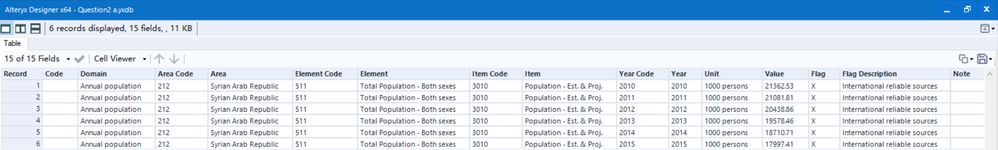

Question_2_B:

Which countries have hosted the most refugees from Syria (top 10) in 2015? How many?

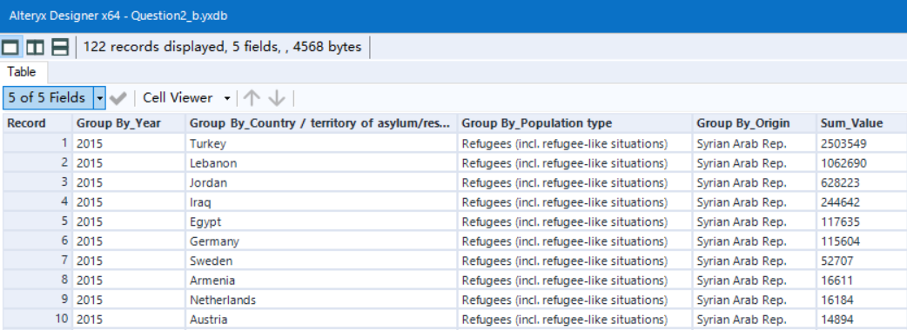

How many: Sum(4772927)

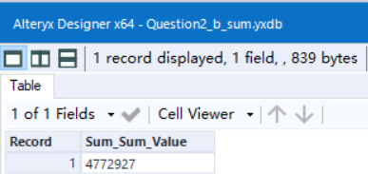

Question_2_C: Provide a comparison between the number of refugees received by these countries (top 5) and their total population

**First country**

Turkey_total_Population_2015 = 77700000

Refugees = 2503549

Comparison = 2503549/77700000 = 3.2%

**Second country**

Lebanon_total_Population_2015 = 5850000

Refugees = 1062690

Comparison = 1062690/5850000 = 18.1%

**Third country**

Jordan_Total_Population_2015 = 9160000

Refugees = 628223

Comparison = 628223/9160000 = 6.86%

**Fourth country**

Iraq_Total_Population_2015 = 36120000

Refugees = 244642

Comparison = 244642/36120000 = 0.67%

**Fifth country**

Egypt_Total_Population_2015 = 93780000

Refugees = 117635

Comparison = 117635/93780000 =0.13%

Question 3:

Explain your insights into the Syrian refugee crisis from the data you have.What else of interest did you find in the data? How would you present the results?

**Answer:**

According to the data I have. Since the year 2010 to the year 2015 The Total population of the Syrian Arab Republic country is decreasing. Is it associated with more Refugees are send it to other country every single year?

As we can see the data of Lebanon percentage. Refugees contains 18% of their total population. I am interested about the all the other countries percentage of the refugees and their total population and analyze the better way to help the country of asylum accept the Refugees in rationalization way.

The way I think I can present is analyze all the Syrian Refugees during the 2010-2015 and compare it to their total population of the each year. If it’s increasing, it means they sent their refugees more and more of each single year.

Analyze the percentage of all the countries who accept the Syrian Refugees and compare them then we can have the result about how to manage it

Question 4:

What challenges did you face to get to your results? What areas are still not clear to you?

**Answer**: The challenge for me is After I analyze the percentage of all the countries who accept the Syrian Refugees and compare to their total population. The challenge for me is how to manage it by using Alteryx. Also this is a big Data for me. I think trying to merge and manage their data is hard for me.

**PART 2**

The Result I am trying to combine is Labor force participation rate and the Refugees acceptance of the country During the time period 2002 – 2018

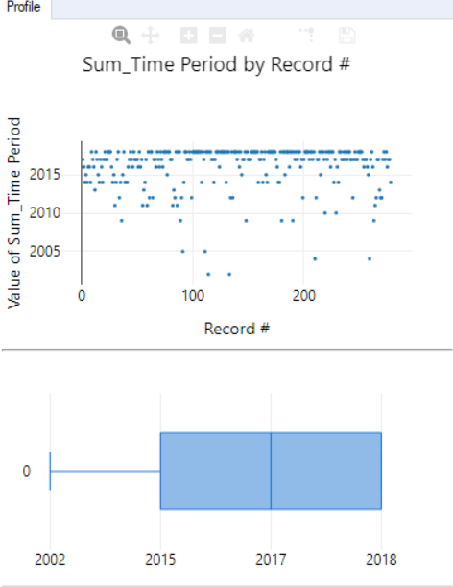

As we can see the Labor rate is increase every each single year. But compare to the data I collected about Territory of asylum. The country that accept the most Refugees has the lower labor rate The time period is during 2002 - 2018

This is the Labor force participation rate of the lower part

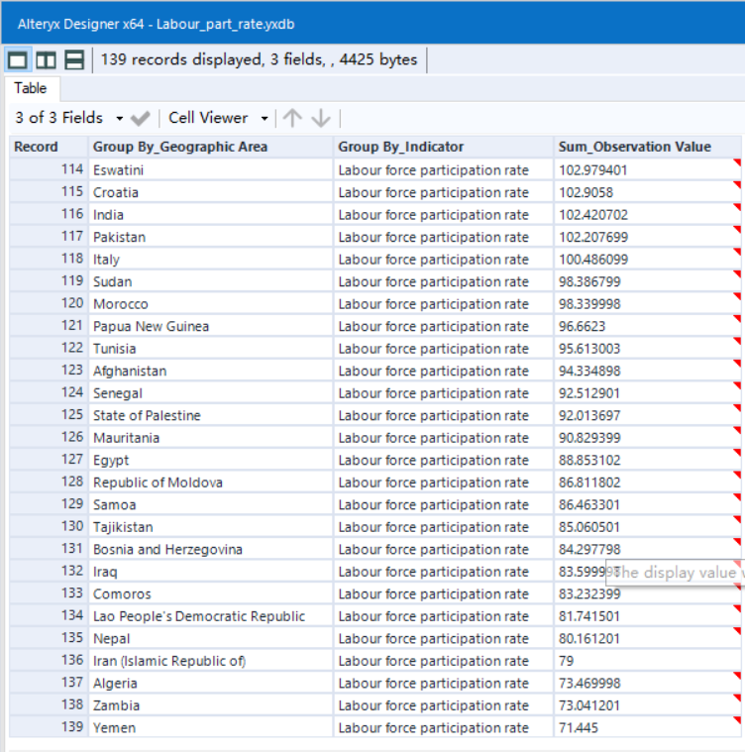

As you can see Sudan, Pakistan, Egypt has the lower labor rate compare to other country, they are around 130 position During 2002-2018. Which is belong to the middle and lower class.

This is the top rate of Refugees acceptance of the country Duing 2002-2018

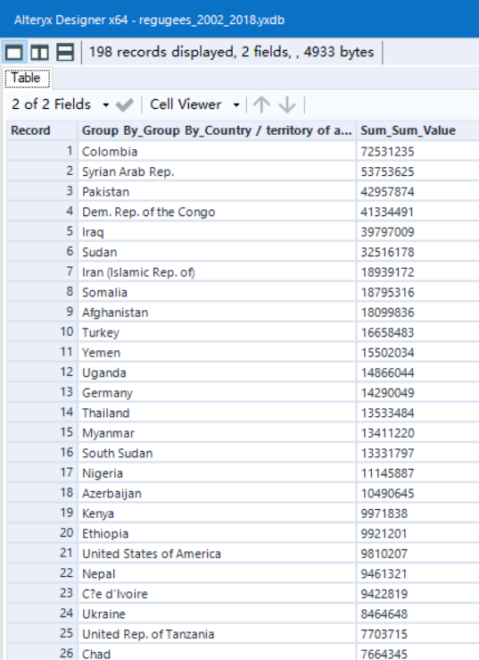

As you can see Sudan, Pakistan are in the top of the list of the accept the refugees. which in my opinion During the time period 2002 -2018: the rate of Refugees acceptance of the country has the opposite rate of the Labor force participation rate